Specifications for Input Event Tracking in the context of FAM processors (to be used in LabDE 1.5)

1. Create a new .NET class called InputEventTracker that can be used in the context of FAM-based applications like ID Shield and LabDE for tracking actual “productive usage” of our product so that we / the user can interpret through put numbers appropriately to assess user’s productivity.
2. The InputEventTracker class will feature the following methods:
a. InputEventTracker(IFileProcessingDB *pDB)
b. RegisterForm(Form f)
c. UnRegisterForm(Form f)
3. The InputEventTracker class shall consider any mouse-down, keydown, or mouse-scroll event in registered forms as an input event.
4. The InputEventTracker shall add records to a new table in the FAM database called “InputEvent” that has the following columns:
a. ID – AutoNumber
b. DateTime – this column only has minute resolution. The seconds part of this value will always be 00. An example value for this column is “12/22/2009 09:34:00 AM”.
c. ActionID (foreign key) – FAM ID of the currently executed action
d. UserID (foreign key) – FAM ID of the currently logged in user
e. MachineID (foreign key) – FAM ID of the machine running the current process
f. PID – Process ID of the current process
g. InputEventCount – a value between 0 and 60 inclusive representing the total number of seconds within the current minute that had at least one input event during that second.
5. The InputEventTracker class shall spawn off a thread to watch for input events from registered forms, and shall keep track of the # of seconds in the current minute that had at least one input event during that second, and add a new record to the InputEvent table in FAM database once a minute with the appropriate data. The design of this feature as well as the above table is such that multiple processes can be adding new rows to the table at the same time and there is no need to serialize access to this table as the InputEventTracker will only be adding rows and will not be modifying rows at any time. The InputEventTracker class shall be designed so that no input event data is lost – i.e. that all data can be properly flushed to the database when the data entry UI is closed, we wait for the spawned off thread to complete its work before completing the closing of the data entry UI, etc.
6. The LabDE data entry task’s property page shall be enhanced with a checkbox with the label “Enable input event tracking”, which by default shall be unchecked. The InputEventTracker class shall be instantiated in the data entry UI only if this checkbox is checked.
7. The FAM database shall have the setting “EnableInputEventTracking” in the DBInfo table and shall default to 0. The InputEventTracker class shall add records to the InputEvent table only if the “EnableInputEventTracking” setting is set to “1”.
8. The FAM database shall have the setting “InputEventHistorySize” and this setting shall default to “30”. This setting shall represent the # of days of history to retain at any given time. Entries older than the prescribed size shall automatically be deleted.
9. The following reports should be added to the FAM (the templates are attached only to show the kind of data we want + the layout; the actual reports need to adhere to our FAM report standards using specific headers, footers, database info tables on top, etc):
a. “Detailed usage report by specific user for specific day”. This shows a grid of white (non productive) and green (productive) cells representing minute durations on a particular day for a particular user”. This also shows the total number of productive minutes for that day. See attached template “Detailed usage report by specific user for specific day.xlsx”
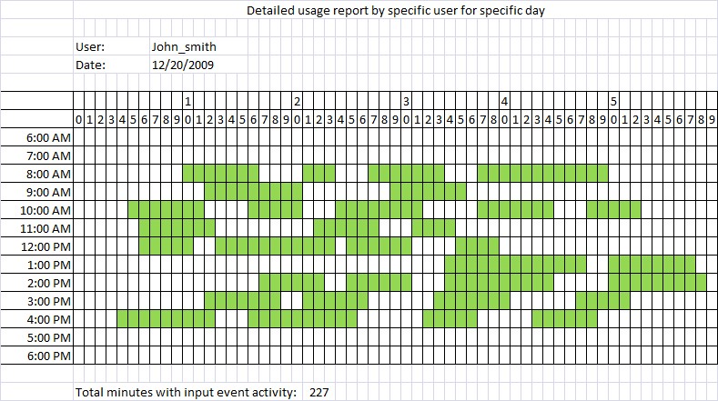
b. “Usage report during custom date range broken down by user”. This shows a breakdown of usage by date and by user. See attached template “Usage report during custom date range broken down by user.xlsx”
